Defining Classes Labs – Part 2

|  |  |  |  |
| --- | --- | --- | --- |
| Use Case Name | Create a location | | |
| Triggering Event | A new location | | |
| Brief Description | Allows the Owner to create a location | | |
| Actors | Owner | | |
| Related Use Cases |  | | |
| Preconditions | Owner has opened the Main Menu. | | |
| Post Conditions | Location is added and available to query | | |
| Flow of activities | Actor | | System |
|  | 1. | Requests to add a new location | Displays a list of locations and prompts for a location name, address and notes |
|  |  | Enters the location name, address and notes | Verifies that name and address have been enter. Generates a unique location identifier. Displays location.  Prompts for confirmation |
|  |  | Confirms entry | Saves the location and returns to the main menu |
| Exception Conditions | * Owner chooses to cancel adding the location | | |

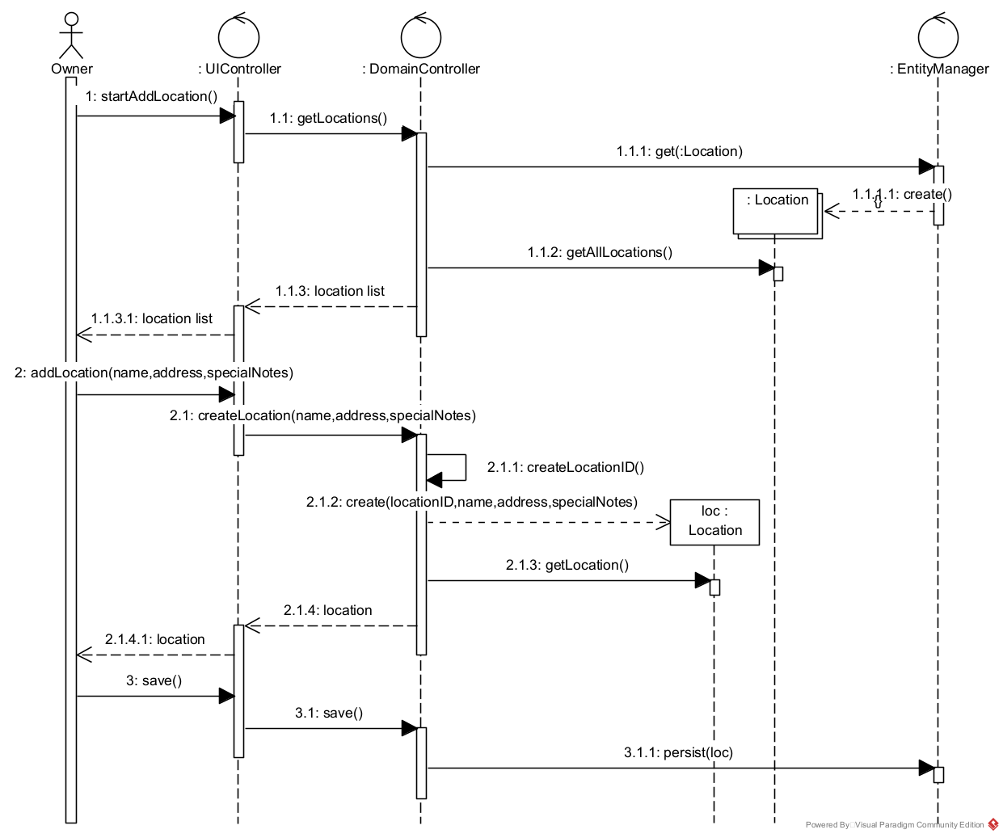

|  |  |  |  |
| --- | --- | --- | --- |
| Use Case Name | Change a location | | |
| Triggering Event | Request to change a location | | |
| Brief Description | Allows the Owner to change a location. | | |
| Actors | Owner | | |
| Related Use Cases |  | | |
| Preconditions | Owner has opened the Main Menu. | | |
| Post Conditions | Location is updated | | |
| Flow of activities | Actor | | System |
|  | 1. | Requests to query locations | Displays a list of locations and prompts for selection. |
|  | 2. | Selects a location | Retrieves the location and prompts for updates |
|  | 3. | Updates location and requests to save | Saves the data |
| Exception Conditions | * Owner chooses to cancel updating location | | |

|  |  |  |  |
| --- | --- | --- | --- |
| Use Case Name | Delete a location | | |
| Triggering Event | Request to delete a location | | |
| Brief Description | Allows the Owner to delete a location | | |
| Actors | Owner | | |
| Related Use Cases |  | | |
| Preconditions | Owner has opened the Main Menu. | | |
| Post Conditions | location is deleted. | | |
| Flow of activities | Actor | | System |
|  | 1. | Requests to query a location | Displays a list of location and prompts to select location. |
|  | 2. | Selects a location | Retrieves the location |
|  | 3. | Confirms deletion | Deletes the location |
| Exception Conditions | * Owner chooses to cancel deleting the location | | |

|  |  |  |  |
| --- | --- | --- | --- |
| Use Case Name | Create a product type | | |
| Triggering Event | Business decides to add a new type of products | | |
| Brief Description | Allows the Owner to create a product type | | |
| Actors | Owner | | |
| Related Use Cases |  | | |
| Preconditions | Owner has opened the Main Menu. | | |
| Post Conditions | product type is added and available to query | | |
| Flow of activities | Actor | | System |
|  | 1. | Requests to add a new product type | Displays a list of product types and prompts for product type and description |
|  |  | Enters product type and description | Verifies that product type and description have been entered. Displays product type.  Prompts for confirmation |
|  |  | Confirms entry | Saves the product type and returns to the main menu |
| Exception Conditions | * Owner chooses to cancel adding the product type | | |

|  |  |  |  |
| --- | --- | --- | --- |
| Use Case Name | Change a product type | | |
| Triggering Event | Request to change a product type | | |
| Brief Description | Allows the Owner to change a product type. | | |
| Actors | Owner | | |
| Related Use Cases |  | | |
| Preconditions | Owner has opened the Main Menu. | | |
| Post Conditions | Product type is updated | | |
| Flow of activities | Actor | | System |
|  | 1. | Requests to query product type | Displays a list of product types and prompts for selection. |
|  | 2. | Selects a product type | Retrieves the product type and prompts for updates |
|  | 3. | Updates product type and requests to save | Saves the data |
| Exception Conditions | * Owner chooses to cancel updating Product type | | |

|  |  |  |  |
| --- | --- | --- | --- |
| Use Case Name | Delete a product type | | |
| Triggering Event | Request to delete a product type | | |
| Brief Description | Allows the Owner to delete a product type | | |
| Actors | Owner | | |
| Related Use Cases |  | | |
| Preconditions | Owner has opened the Main Menu. | | |
| Post Conditions | Product type is deleted. | | |
| Flow of activities | Actor | | System |
|  | 1. | Requests to query a product type | Displays a list of product type and prompts to select product type. |
|  | 2. | Selects a product type | Retrieves the product type |
|  | 3. | Confirms deletion | Deletes the product type |
| Exception Conditions | * Owner chooses to cancel deleting the product type | | |

|  |  |  |  |
| --- | --- | --- | --- |
| Use Case Name | Create an income source | | |
| Triggering Event | A new source of income (a new business venture) | | |
| Brief Description | Allows the Owner to create an income source | | |
| Actors | Owner | | |
| Related Use Cases |  | | |
| Preconditions | Owner has opened the Main Menu. | | |
| Post Conditions | Income source is added and available to query | | |
| Flow of activities | Actor | | System |
|  |  | Requests to add a new income source | Displays a list of income sources prompting for an income source identifier and description. |
|  |  | Enters income source identifier and description | Verifies that income source identifier and description have been entered  Prompts for confirmation |
|  |  | Confirms entry | Saves the income source and returns to the main menu |
| Exception Conditions | * Owner chooses to cancel adding income source | | |

|  |  |  |  |
| --- | --- | --- | --- |
| Use Case Name | Change an Income source description | | |
| Triggering Event | Request to change an income source description | | |
| Brief Description | Allows the Owner to change an income source description | | |
| Actors | Owner | | |
| Related Use Cases |  | | |
| Preconditions | Owner has opened the Main Menu. | | |
| Post Conditions | Income source description is updated | | |
| Flow of activities | Actor | | System |
|  | 1. | Requests to query an income source | Displays a list of income sources and prompts for income source. |
|  | 2. | Selects an income source | Retrieves the income source description and prompts for updates |
|  | 3. | Updates description and requests to save | Verifies that description was entered.  Saves the data |
| Exception Conditions | * Owner chooses to cancel updating the income source description | | |

|  |  |  |  |
| --- | --- | --- | --- |
| Use Case Name | Delete an income source | | |
| Triggering Event | Request to delete an income source | | |
| Brief Description | Allows the Owner to delete an income source | | |
| Actors | Owner | | |
| Related Use Cases |  | | |
| Preconditions | Owner has opened the Main Menu. | | |
| Post Conditions | Income source is deleted. | | |
| Flow of activities | Actor | | System |
|  | 1. | Requests to query an income source | Displays a list of income sources and prompts to select income source. |
|  | 2. | Selects an income source | Retrieves the income source |
|  | 3. | Confirms deletion | Deletes the income source |
| Exception Conditions | * Owner chooses to cancel deleting the income source | | |

